Design Review

* Robot at 2nd Qualifier

horizontal line **Date:** Sat, Jan 21, 2017

**Location:** Gater Bowl Qualifier, Greenwich, CT

|  |  |  |  |
| --- | --- | --- | --- |
| **Major Milestones:** |  | **Completion Goal** | **Completed** |
| Mountain Matchup Qualifier - Ridgefield |  | Dec 4, 2016 | Yes |
| Gator Bowl Qualifier - Greenwich |  | Jan 21, 2017 | Yes |
| Determined Tigers Qualifier – West Hartford |  | Feb 4, 2017 |  |
| Battle at the Beach – CT State Championship |  | Feb 18, 2017 | Qualified |
| East Super Regional – Scranton, PA |  | Mar 17-19, 2017 |  |
| Worlds Competition |  | Apr 2017 |  |
| Post competition – Hatter’s Scrimmage |  | May 16, 2017 |  |

**Requirements:**

|  |  |  |  |
| --- | --- | --- | --- |
| **Physical Systems –Requirements** | **Required?** | **Status** | **Achieved** |
| Push Beacons | Yes | Improved | 3 one touch |
| Side by side beacon pushers | Nice to have | None |  |
| Shoots particles | Yes | None | None |
| Shoots multiple particles (reloads) | Yes | None | None |
| Maneuverable – uses Mecanum Wheels | Nice to have | Good | Good |
| Lifts Cap Ball | Yes | None | None |
| Places Cap Ball on C.Vortex | Nice to Have | Push w bumper | None |

**Agenda:** Review Robot status at 2nd Qualifier

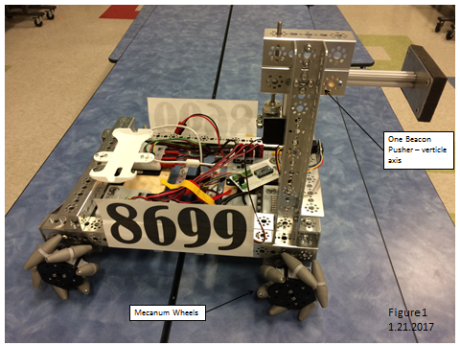

***Updates from 1st Qualifier:***

* See figure 1.
* Remounted electronics
* Added color sensors to the bottom of the robot to sense the white line – start of autonomous programming. Fabricated multiplexer to communicate with multiple sensors.
* Replaced wooden beacon pushers with aluminum frame construction.
  + Rotates horizontally into position, retracts for protection when traveling.
  + Rotated in and out every time used.
  + Reaches far in front of front wheels
  + Reinforced shafting with hard stop and vertical supports
  + Added foam (compliant facing) on aluminum pushing surface

***Observations:***

* Seeded 8th, was not in finals.
* Robot stopped working one match.
* Beacon pusher inconvenient to use – swing out then swing in - slow.
* The wheels worked well – maneuverable system, light. Possibly not as free spinning as before.
* Autonomous starting to be programmed – possible to get cap ball and park in autonomous.

***Suggested concepts for improvement:***

* Redesign beacon pusher – quicker, more rugged.
* Develop particle shooter
* Develop particle re-loader
* Develop autonomous program

|  |  |  |
| --- | --- | --- |
| **Action Items** | **Assigned** | **Date/Goal** |
| Concepts for beacon pusher redesign | Team | Jan 2017 |
| Concepts for shooter | Team | Jan 2016 |

|  |  |  |  |
| --- | --- | --- | --- |
| **Prepared By:** | Chandler | **Date:** |  |
| **Overview By:** | G. Edward | **Date:** |  |